**Factors affecting the academic performance**

PREPARED BY

**Anamika Agarwal (2017BTECHCSE203)**

FACULTY GUIDE

**Dr. Umesh Gupta**



**Department of Mathematics**

**Institute of Engineering and Technology (IET)**

**JK Lakshmipat University Jaipur**

**october 2018**

# CERTIFICATE

This is to certify that the Practice School-2 project work entitled **“Maths Project: factors affecting the academic performance”** submitted by **Anamika Agarwal(2017BTECHCSE203),** towards the partial fulfillment of the requirements for the degree of **Bachelor of Technology in CSE** of JK Lakshmipat University Jaipur is the record of work carried out by them under my supervision and guidance. In my opinion, the submitted work has reached a level required for being accepted for Maths Project Examination.

|  |
| --- |
| **Dr. Umesh Gupta** |
| Associate Professor |
| Department of Mathematics |
| Institute of Engineering & Technology (IET) |
| JK Lakshmipat University Jaipur |

|  |  |
| --- | --- |
|  |  |
|  |  |
|  |  |
| Date of Submission - 15/11/2018 | |  |  | | --- | --- | |  |  | |  |  | |  |  | |  |  | |  |  | |

# 

# ACKNOWLEDGEMENT

We would like to express our heartfelt gratitude to Dr. Umesh Gupta and Dr. Richa Sharma for their valuable time and guidance that made the project work possible. They guided us about the basics of the project. How to prepare a questionnaire on various factors that may affect the academic performance of students which has helped us greatly in completing the project.They have helped us to how to proceed towards the completion of project “ FACTORS AFFECTING THE ACADEMIC PERFORMANCE ”.

We are also highly obligied by the support of the student of the university for giving us their time to fill the questionnaire for the project.

Sincerely yours,

Anamika Agarwal(2017BTECHCSE203)

# 

# ABSTRACT

This project was prepare to examine different factors that affecting the academic performance of students. The respondents for this study were JK Lakshmipat university students. A survey was conducted by using a questionnaire for information gathering about different factors relating to academic performance of students

There are certain statistics methods that can be used to find the factors affecting the academic performance . These methods include Pearson correlation ,spearman correlation,ANOVA,multiple regression. We are using Pearson correlation in this project. The Pearson Correlation was used to highlight the important factors.The analysis was conducted with the help of the statistical package for social Sciences (SPSS).

# List of Tables , Figures, Excel and SPSS data

2.1.1 data of student score above 70% in 12th

# 2.1.2 average of all factors of student score above 70%

2.1.3 data of student score below 70% in 12th

# 2.1.4 average of all factors of student score below 70%

2.1.5 average of complete data

2.1.6 spss report on dataset1(pearson correlation b/w 12th percentage and sem1 cgpa)

2.1.7 spss report on dataset1(pearson correlation b/w 12th percentage and sem2 cgpa)

2.1.8 spss report on dataset1 Descriptive Statistics

2.1.9 spss report on dataset2(pearson correlation b/w 12th percentage and sem1 cgpa)

2.1.10 spss report on dataset2(pearson correlation b/w 12th percentage and sem2 cgpa)

2.1.11 spss report on dataset2 Descriptive Statistics

Contents

CERTIFICATE ii

ACKNOWLEDGEMENT iii

ABSTRACT iv

List of Tables ,figures,excel and spss data v

CHAPTER 1 : INTRODUCTION vii

1.1 Problem Statement vii

1.2 Methodology Adopted vii

1.3 Method Used: Pearson correlation using spss vii

CHAPTER 2 : DATA AND CALCULATIONS x

2.1 Tables, ,figures,excel and spss data: x

# INTRODUCTION

## Problem Statement

To identifying the factors that affecting the academic performance of students we need to prepare a questionnaire on various factors that may affect the academic performance of students. This will give a data set of various factors. With this dataset we will be able to analyse The factors and apply proper statistical method(s) to find out the appropriate factors affecting students academic performance.

## Methodology Adopted

We have prepared questionnaire in hardcopy and shared it to the students to collect the data we also have prepared questions in google spreadsheet and shared it among the students of various institutes to collect the data. By using these various methodologies we have collected around 90 student’s data that covers the information like student’s academic and learning behaviour. Out of 90 respondents, 82 questionnaires were treated as adequate and the remaining 8 questionnaires were either not filled properly or were rejected due to inconsistency in the responses. Thus the response rate was 91.1 %.

## Method Used: correlation

## Correlation is a statistical tool that helps to measure and analyze the degree of relationship between two variables.Correlation analysis deals with the association between two or more variables.

### Karl Pearson's Coefficient of Correlation

### Pearson’s ‘r’ is the most common correlation coefficient. Karl Pearson’s Coefficient of Correlation denoted by- ‘r’ The coefficient of correlation ‘r’ measure the degree of linear relationship between two variables say x & y.

### Karl Pearson’s Coefficient of Correlation denoted by- r -1 ≤ r ≥ +1 . Degree of Correlation is expressed by a value of Coefficient . Direction of change is Indicated by sign ( - ve) or ( + ve)

### When deviation taken from actual mean:

### r(x, y)= Σxy / √ Σx² Σy²

### When deviation taken from an assumed mean:

### r = N Σdxdy - Σdx Σdy /√N Σdx²-( Σdx)² √N Σdy²-( Σdy)²

### Spearman’s Rank Coefficient of Correlation

### 

When statistical series in which the variables under study are not capable of quantitative measurement but can be arranged in serial order, in such situation pearson’s correlation coefficient can not be used in such case Spearman Rank correlation can be used.

R = 1- (6 ∑ D2 ) / N (N 2 – 1)

R = Rank correlation coefficient

D = Difference of rank between paired item in two series.

N = Total number of observation.

# DATA AND CALCULATIONS

## Tables, , Figures , Excel and SPSSs data:

2.1.1 data of student score above 70% in 12th

### 

### 

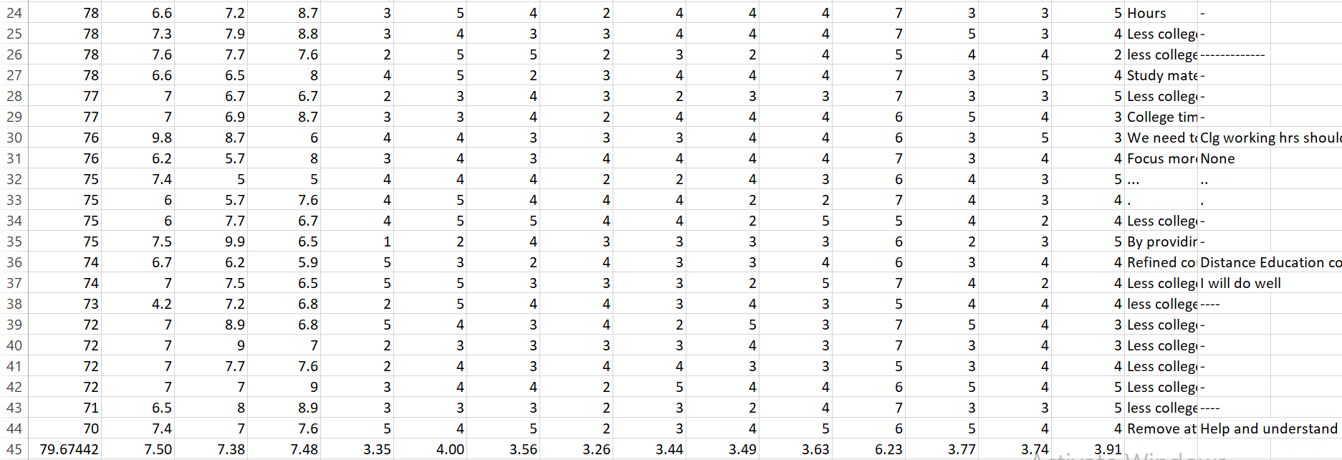

# 2.1.2 average of all factors of student score above 70%

2.1.1 data of student score below 70% in 12th

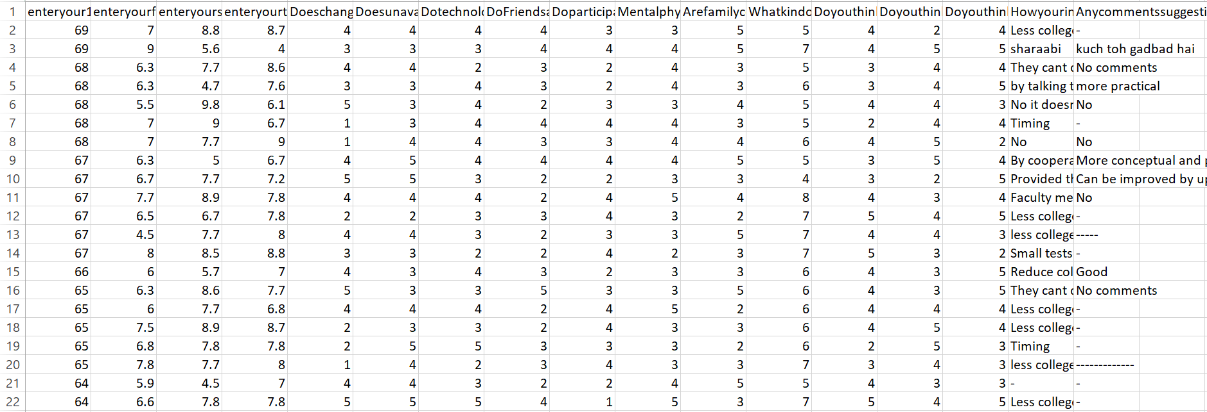

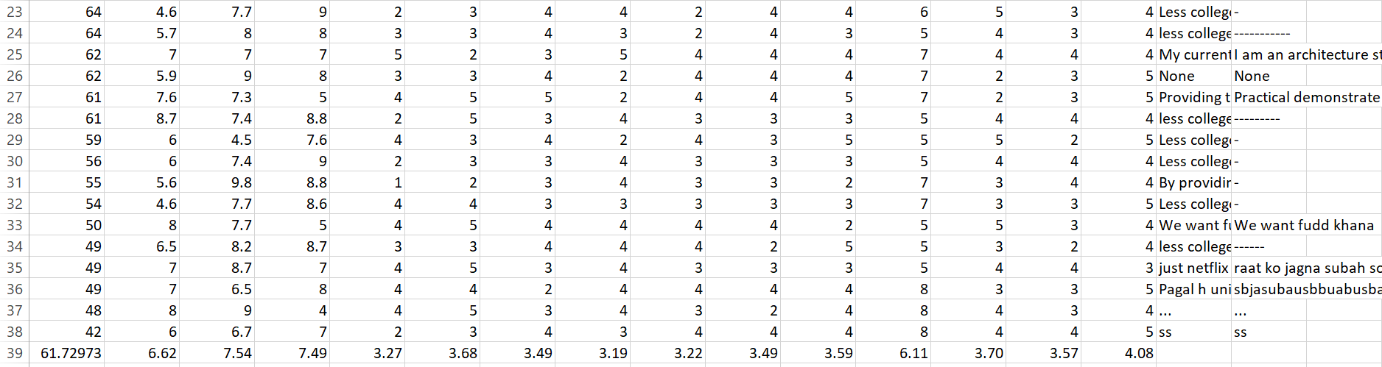

# 2.1.2 average of all factors of student score above 70%

2.1.5 average of complete data

2.1.6 spss report on above 70%(pearson correlation b/w 12th percentage and sem1 cgpa)

|  |  |  |  |
| --- | --- | --- | --- |
| **CorrelationsCorrelations, table, 1 levels of column headers and 2 levels of row headers, table with 4 columns and 9 rows** | | | |
|  | | Twelth | SemOne |
| Twelth | Pearson Correlation | 1 | .667** |
| Sig. (2-tailed) |  | .000 |
| N | 43 | 43 |
| SemOne | Pearson Correlation | .667** | 1 |
| Sig. (2-tailed) | .000 |  |
| N | 43 | 43 |
| **. Correlation is significant at the 0.01 level (2-tailed). | | | |
|  |  |  |  |

2.1.7 spss report on above 70%(pearson correlation b/w 12th percentage and sem2 cgpa)

|  |  |  |  |
| --- | --- | --- | --- |
| **CorrelationsCorrelations, table, 1 levels of column headers and 2 levels of row headers, table with 4 columns and 8 rows** | | | |
|  | | Twelth | SemTwo |
| Twelth | Pearson Correlation | 1 | -.063 |
| Sig. (2-tailed) |  | .688 |
| N | 43 | 43 |
| SemTwo | Pearson Correlation | -.063 | 1 |
| Sig. (2-tailed) | .688 |  |
| N | 43 | 43 |
|  |  |  |  |

2.1.8 spss report on above 70% Descriptive Statistics

|  |  |  |  |  |  |
| --- | --- | --- | --- | --- | --- |
| **Descriptive StatisticsDescriptive Statistics, table, 1 levels of column headers and 1 levels of row headers, table with 6 columns and 6 rows** | | | | | |
|  | N | Minimum | Maximum | Mean | Std. Deviation |
| Twelth | 43 | 70.00 | 94.00 | 79.6744 | 6.31974 |
| SemOne | 43 | 4.20 | 10.00 | 7.4953 | 1.12968 |
| SemTwo | 43 | 5.00 | 9.90 | 7.3767 | 1.02976 |
| Valid N (listwise) | 43 |  |  |  |  |
|  |  |  |  |  |  |

2.1.9 spss report on below 70%(pearson correlation b/w 12th percentage and sem1 cgpa)

|  |  |  |  |
| --- | --- | --- | --- |
| **CorrelationsCorrelations, table, 1 levels of column headers and 2 levels of row headers, table with 4 columns and 8 rows** | | | |
|  | | Twelth | SemOne |
| Twelth | Pearson Correlation | 1 | .005 |
| Sig. (2-tailed) |  | .978 |
| N | 37 | 37 |
| SemOne | Pearson Correlation | .005 | 1 |
| Sig. (2-tailed) | .978 |  |
| N | 37 | 37 |
|  |  |  |  |

2.1.10 spss report on below 70%(pearson correlation b/w 12th percentage and sem2 cgpa)

|  |  |  |  |
| --- | --- | --- | --- |
| **CorrelationsCorrelations, table, 1 levels of column headers and 2 levels of row headers, table with 4 columns and 8 rows** | | | |
|  | | Twelth | SemTwo |
| Twelth | Pearson Correlation | 1 | -.072 |
| Sig. (2-tailed) |  | .670 |
| N | 37 | 37 |
| SemTwo | Pearson Correlation | -.072 | 1 |
| Sig. (2-tailed) | .670 |  |
| N | 37 | 37 |
|  |  |  |  |

2.1.11 spss report on below 70% Descriptive Statistics

|  |  |  |  |  |  |
| --- | --- | --- | --- | --- | --- |
| **Descriptive StatisticsDescriptive Statistics, table, 1 levels of column headers and 1 levels of row headers, table with 6 columns and 6 rows** | | | | | |
|  | N | Minimum | Maximum | Mean | Std. Deviation |
| Twelth | 37 | 42.00 | 69.00 | 61.7297 | 7.28258 |
| SemOne | 37 | 4.50 | 9.00 | 6.6189 | 1.05537 |
| SemTwo | 37 | 4.50 | 9.80 | 7.5432 | 1.38775 |
| Valid N (listwise) | 37 |  |  |  |  |
|  |  |  |  |  |  |